Paper title in 16 pt, initial capital for the first word, centred

A.B. Dupont^{a,*} , C.D. Jones^{b}, E.F. Brown^{c}

ª Laboratoire IMS, University of Bordeaux, Talence, France
^{b} Nodal Electronics, Inc., 2345 Any Street, New York, NY 12345, USA
^{c} Institute of Microelectronics, Foxville, Victoria 1234, Australia

Abstract

The Abstract should be 75-200 words long, summarizing the work and placing it in an appropriate context. The text should be fully justified, and the abstract should be surrounded by horizontal rules.

1. Main headings in bold, initial capital

The length of the submitted full paper must be minimum 4 pages, maximum 6 pages.
The first paragraph after each new heading should be indented. Text should be left and right justified, providing a straight vertical margin on both sides. Use 10 point Times Roman type (or similar) throughout.
All headings in the main text should be numbered throughout, following the scheme shown here. Leave a blank line after main and secondary headings.
The first word of every paragraph should be indented, as here. There should be no space between paragraphs, but do leave a one-line space before each new main, secondary or tertiary heading.
The typing area is 160 mm by 215 mm. With the exception of the title block and the Abstract, all text should be set in two-column format, leaving a gap of approximately 10 mm between the columns. Number each page of the typescript lightly in blue pencil. Final page numbers and running headlines will be added by the publisher. Header material (title, authors, affiliations, abstract) should be correctly positioned as shown above. All subsequent pages (except the last) should occupy the full type area.

1.1. Secondary headings

Use italic type for secondary headings (subheadings), with an initial capital for the first word. If necessary, a tertiary heading level may also be used.

1.1.1. Tertiary headings
Use italic type for tertiary headings (subsubheadings), with an initial capital for the first word only. Do not leave a blank line after the heading.

2. Illustrations, tables and equations

2.1. Illustrations

All illustrations (line drawings, photographs, etc) are to be referred to as ‘Figures’ and numbered in sequence. They should be inserted appropriately in the text, with the figure number and caption below. Ensure that all lettering is fully legible and not too small. All illustrations must be cited in the text (see Fig. 1).
Figures may span one or both columns (see Fig. 2), depending on their size and complexity, but should normally appear at the top of a page or column.
Table 1
Deflection data for beams under vertical loadingª

Material | Deflection x (mm) | Deflection y (mm)
Concrete | 0.123 | 0.524
Steel | 0.145 | 0.246
Composite | 0.133 | 0.415

ªTables should be set in 9 pt. Footnotes should be placed directly below the closing rule.
Diagrams writings must be clearly readable and the font size should never be smaller than 8pt.

2.2. Tables

Table headings appear above the table, which should be centred on the column or the page as size dictates. Vertical rules should be avoided, and authors should try to ensure that tables are clearly and consistently presented (see Table 1).

2.3. Equations

Leave a blank line above and below each equation. Equations should be indented, and the equation numbers should be right justified. Equation numbers should be sequential throughout. All equations should be typed (see Eq. 1).
Fig. 1. An example of a figure. Vector format is warmly recommended, such as .wmf and .emf. If using Microsoft Word to edit the document, “text boxes” are recommended for a correct placement of figures. For instance, this text box is placed and automatically held at the top-left corner of the page.
x = 2b² + 4 sin θ (1)

All variables must be defined. Use italic for variable names (e.g. x) and roman for operators and functions (e.g. cos). Authors may include a nomenclature section.

3. Citations to references
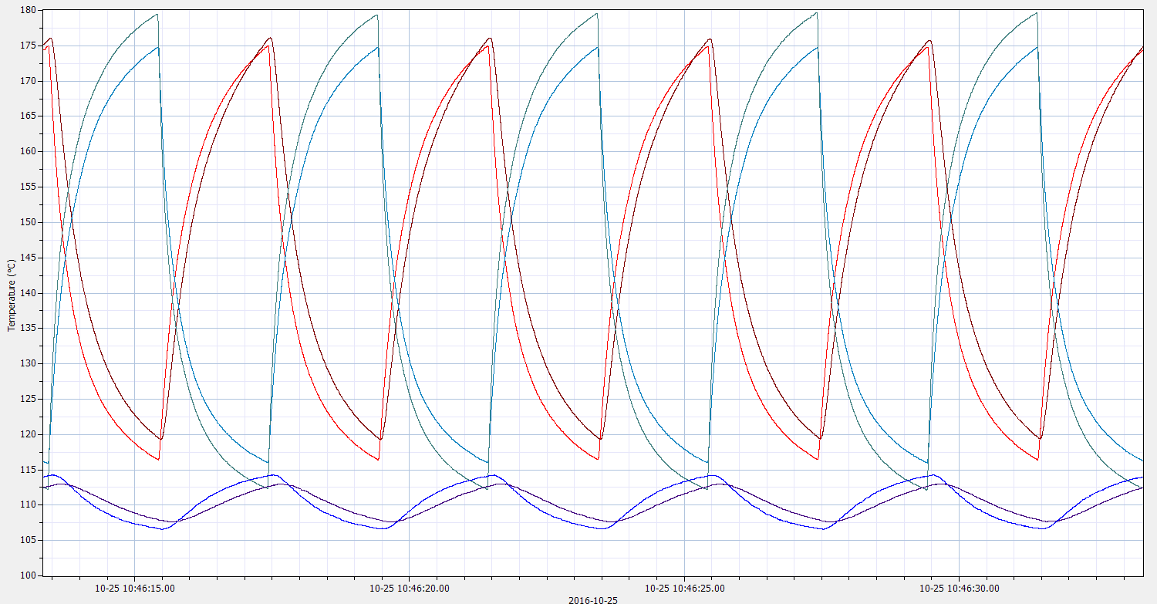
Fig. 2. An example of a figure spanning over two columns.

Use the numerical system. References should be numbered sequentially throughout the text, as shown in the following examples: Hurley and Grant [1] have shown that…, in a previous paper [2] the species was identified as… All numbered references must be listed at the end of the paper in the numerical order of first appearance in the text, according to the formats in the References section, for journals [1], books [2] and reports [3] respectively. Where a particular reference is cited more than once, use the same number on each occasion. Ensure that every reference is cited in the text, and that all citations are matched by references in the list. Multiple references should be indicated thus: [1,2,3].

Acknowledgements

Place any acknowledgements here, after the main text and before the References.
The headings for Acknowledgements, Appendix and References should be treated as main headings, except that they should not be numbered.

Appendix A. Authors’ checklist

The document must be converted and submitted in PDF format with embedded fonts. Please, do not password-protect your document in order to facilitate reviewers’ job.
Please, check that the final PDF version is minimum 4, maximum 6, pages long.
Place any appendices after the Acknowledgements, and before the Reference list. If you have more than one appendix, number them A, B, C, etc. Subheadings may be added in the appendices as shown here.

References

[1] P. Cova, N. Delmonte, A.K. Solomon, A. Castellazzi, Thermal design optimization of novel modular power converter assembly enabling higher performance, reliabilityand availability, Microelectron. Reliab. 64 (2016) 507–512.
[2] J.C. Irvin, The reliability of GaAs FETs, in: J. Di Lorenzo, D. Khandelwal (Eds.), Ch. 6 in GaAs FET Principles and Technology, Artech House, Mass. 1985, pp. 348–400.
[3] COMSOL Multiphysics, AC/DC Module User's Guide, 2015.
[4] A.K. Solomon, A. Castellazzi, N. Delmonte, P. Cova, Highly integrated low-inductive power switches using double-etched substrates with through-hole viases, Proc. ISPSD 2015, pp. 329–332.

